

# **LAWYERS ALERT**

**UPDATED FINDINGS ON PETTY OFFENCES VIOLATIONS IN NIGERIA**

**IN**

**PARTNERSHIP WITH**

**OPEN SOCIETY INITIATIVE FOR WEST AFRICA (OSIWA)**

**OCTOBER, 2021**

**INTRODUCTION**

Vulnerable and poor citizens whether in Nigeria or across the world are the population that suffers most human rights abuses associated with petty offences. As the hashtag to the global campaign to decriminalize petty offences goes, #povertyisnotanoffence. In Nigeria today, 70% of those awaiting trials in our correctional centres are persons accused of petty offences.

Petty Offences are offences other than felonies or misdemeanours that targets the poor in any society. Petty offences are said to “wear the face of Poverty”. Examples of petty offences include hawking, loitering, alms-seeking, etc. As earlier stated the Nigerian Correctional Centers and other detention Centers are today largely populated by these offences with by Petty Offences-awaiting-trial inmates, with huge resources expended by the state for their prosecution. The African Court Advisory Judgement declared petty offences as unconstitutional and urged African governments to decriminalize and remove them from statute books.

Notwithstanding the above, there is the paucity of scientific data to effectively carry out advocacy for the decriminalization of petty offences. This is the gap this report seeks to fill. Lawyers Alert in the last 2 years has been monitoring and documenting human rights violations associated with petty offences in Nigeria. This updated report is a compendium of reported petty offences violations between April 2021 – September 2021. The data used in this report is drawn from inputs made into Lawyers Alert Documentation [Tool](https://www.lawyersalertng.com/analysis_08.php) (LadockT).

In validation of the allegation of tightening of the civic space in Nigeria, Disobedience to Constituted Authorities ranked highest amongst other petty offences at 37%, even though it reflects a decline as against the past report of 43%. As in the past report, Wandering/Loitering ranked second. With regards to States with the highest violations, as in the last report covering the period April 2020 – September 2020, Lagos State ranked highest at 29% and the Federal Capital Territory at coming second at 20%. At the LGA level, Abuja Municipal ranked highest at 13% and Lagos Island second at 12%.

Data of violations is obtained from our partners working within communities across the country and fed into our Online Tool for automatic analysis to evidence types, age, location, sex and trends. The data is therefore tested and the integrity is hereby assured. Interventions for petty offences can be better informed than when situated against scientific data as evidenced in this report.

This report validates the need for the decriminalization of petty offences in Nigeria and it is the belief of Lawyers Alert that these scientific findings will

hasten legislators resolve at the federal and state level in decriminalizing these offences.

Lawyers Alert acknowledges the support and partnership of Open Society Initiative for West Africa (OSIWA). We are indebted to several individuals and organizations who referred cases to us which was a huge resource in terms of efforts at populating the Tool.

Rommy Mom

President, Lawyers Alert.

**VIOLATION ANALYSIS BASED ON TYPES OF PETTY OFFENCES**

Petty offences violations in this report were captured and documented using the below which was agreed on by Civil Society Groups and Activists working on petty offences in Nigeria. They include;

* Wandering/Loitering
* Disobedience to Parents/Constituted Authorities
* Alms seeking
* Hawking
* Public Display of Affection
* Violation of Traffic/Wrong parking
* Breach of promise
* Commercial sex work
* Indiscriminate disposal of waste
* Sexual minorities
* Rogue/Vagabond

In this reporting period, **Disobedience to Parents/Constituted Authority** ranked highest as evidenced by the charts below with 37% closely followed by **Wandering/Loitering** with 18% and **Rogue/Vagabond** ranked third with 17%. **Commercial Sex Work** came fourth with 7% and **Sexual Minorities** ranked fifth at 6%. **Hawking** was captured at 5% while violations associated with **Breach of Promise**, **Violation of Traffic/Wrong Parking**, **Public Display of Affection**, **Indiscriminate Disposal of Waste** and **Alms Seeking** was captured at 2% respectively.

The below charts reflect the above;

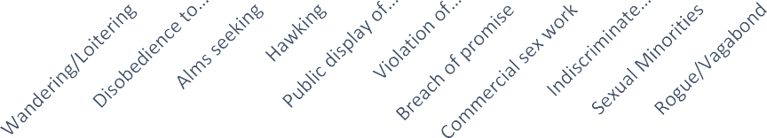

**BAR CHART ANALYSIS OF PETTY OFFENCES VIOLATIONS**

1600

1400

1200

1000

800

600

400

200

0

***Fig 1: Bar Chart analysis of Petty Offences violation.***

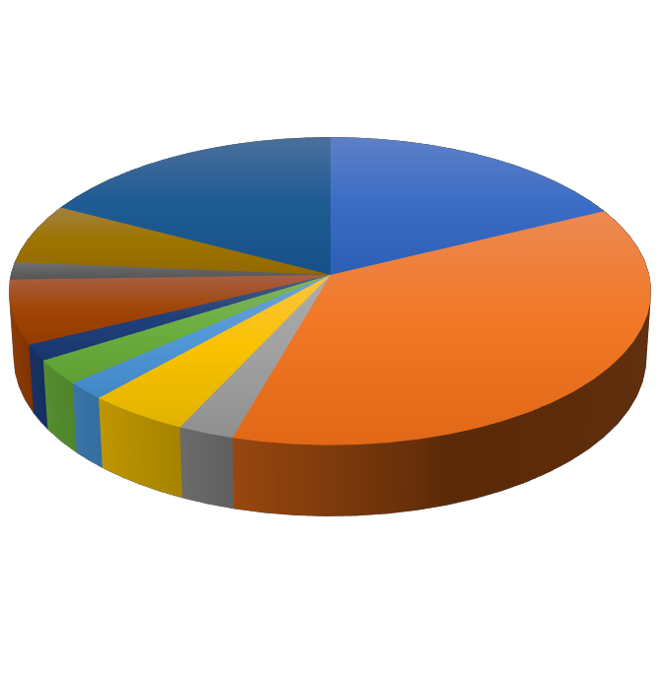

**VIOLATIONS BASED ON TYPES OF PETTY OFFENCES**

Indiscriminate Sexual Minorities

disposal of waste 6% 2%

Rogue/Vagabond

17%

Wandering/Loitering 18%

Wandering/Loitering

Disobedience to parents

/Constituted authority Alms seeking

Hawking

Disobedience to

parents /Constituted

authority Public display of affection

37%

Violation of traffic/wrong parking

Breach of promise

Hawking

5%

Commercial sex work

7%

Commercial sex work

Breach of promise

2%

Indiscriminate disposal of waste

Public display of

affection 2%

Alms seeking

2%

Violation of

traffic/wrong parking 2%

Sexual Minorities

***Fig 2: Violations based on types of Petty Offences.***

|  |  |  |  |  |  |  |
| --- | --- | --- | --- | --- | --- | --- |
| **Types of Petty Offences** | **March 2020** | **September 2020** | **March 2021** | **September 2021** | **Increase** | **Decrease** |
| Wandering/Loitering | 26% | 25% | 22% | 18% | - | 4% |
| Breach of Promise | 1% | 2% | 1% | 2% | 1% | - |
| Disobedience to Parents/Constituted Authority | 28% | 31% | 43% | 37% | - | 6% |
| Violation of Traffic Rules/Wrong Parking | 1% | 1% | 1% | 2% | 1% | - |
| Indiscriminate Disposal of Waste | 0% | 0% | 0% | 2% | 2% | - |
| Alms Seeking | 0% | 0% | 0% | 2% | 2% | - |
| Commercial Sex Work | 10% | 10% | 7% | 7% | - | - |
| Sexual Minorities | 4% | 3% | 4% | 6% | 2% | - |
| Hawking | 4% | 3% | 3% | 5% | 2% | - |
| Public Display of Affection | 0% | 0% | 1% | 2% | 1% | - |
| Rogue/Vagabond | 26% | 25% | 18% | 17% | - | 1% |

***Table 1: Table showing percentage increase & decrease on the types of Petty Offences***

The above table shows the trends of the types of petty offences as captured in past and this reporting period. **Wandering/Loitering** in March 2020 was captured at 26%. In September 2020, it was recorded at 25% which reflects a decline of 1%, in March 2021, there was a further to 22% which is a decrease of 3%. In September 2021, it was captured at 18%, which is a decrease of 4%. **Disobedience to Parents/Constituted Authority** was initially captured at 28% in the first report produced in March 2020. An increase of 3% was shown in the last report in September 2020 i.e., to 31% and another increase of 12% in March 2021 to 43%. In September 2021 however, a decrease of 6% was recorded, i.e., 37%. **Breach of Promise** was captured at 1% in March 2020. An increase of 1% was recorded in September 2020, a decrease of 1% in March 2021 and an increase of 1% in September 2021. **Violation of Traffic Rules/Wrong Parking** was documented at 1% in March 2020, September 2020 and March 2021 respectively. There was an increase to 2% in September 2021. **Commercial Sex Work** was captured at 10% in March and September 2020 respectively with a decline to 7% in March 2021 and September 2021 respectively. Violations associated with **Sexual Minorities** was captured at 4% in March 2020 and a decline to 3% recorded in September 2020. In March 2021, an increase of 1% was seen, and in September 2021, an increase to 2% was captured, i.e., 6%. **Hawking** in March 2020 was captured at 4%. In September 2020 and March 2021, it was recorded at 3%. 1n September 2021 however, an increase to 5% was recorded. **Rogue/Vagabond** was documented at 26% in March 2020, a decrease of 1%, 7% and 1% was recorded in September 2020, March 2021 and September 2021 respectively. **Public Display of Affection** in March 2020 and September 2020 was captured at less than 1% but an increase of 1% was recorded in March 2021. A further increase to 2% was documented in September 2021. **Indiscriminate Disposal of Waste** and **Alms Seeking** and for the first three reports produced have stayed constant with an insignificant reportage of less than 1%. In this reporting period however, an increase of 2% each was recorded.

**STATES WITH HIGHEST PETTY OFFENCES VIOLATION RATES.**

This report covers the entire country given that the online documentation tool captures all States across the 6 geo-political zones of the country, even though this project is situated in about 6 states in Nigeria. In this reporting period, Lagos State ranked highest with 29%, closely followed by the Federal Capital Territory with 20%. Benue State ranked third with 10%, with Plateau at 9%. Bauchi State had 7% with Kano and Anambra States next at 5% respectively. Delta, Rivers, Borno and Abia were recorded at 2% each. Niger, Akwa Ibom, Kaduna, Edo, Ogun, Oyo and Katsina had 1% respectively. Kwara, Ebonyi, Osun, Ondo and Imo states present the least number of reported violations at less than 1% respectively.

**STATES WITH HIGHEST PETTY OFFENCES VIOLATIONS**

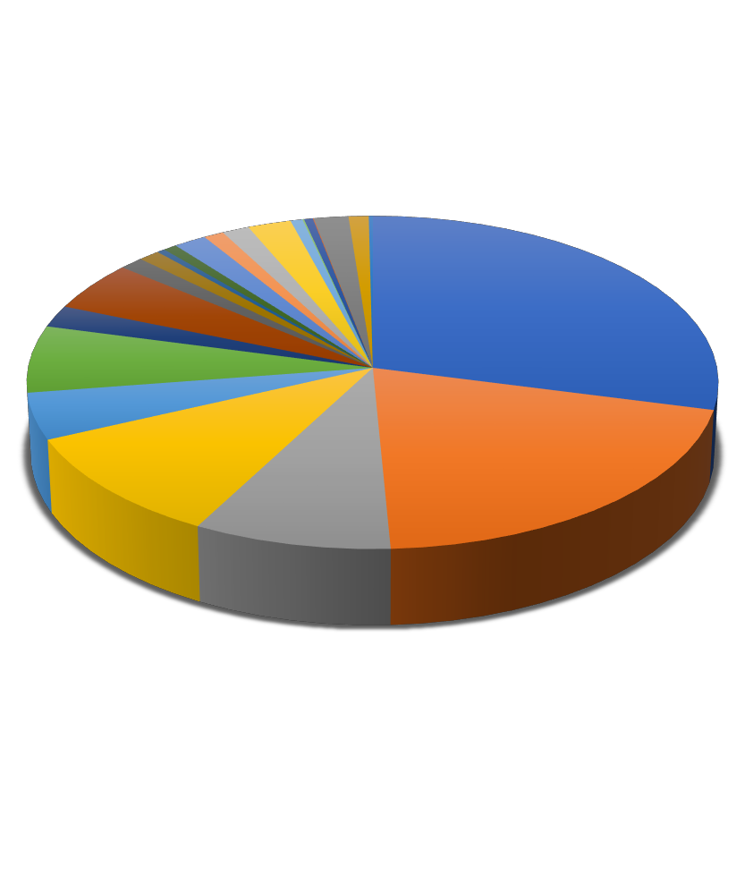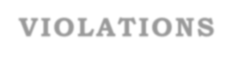

Kaduna 1%

Akwa Ibom 1%

Delta 2%

Bauchi 7%

Niger 1%

Anambra 5%

Rivers 2%

Benue 10%

Edo 1%

Ondo 0%

Abia 2%

Kano 5%

Osun

0% Ogun

1%

Plateau 9%

Imo 0%

Ebonyi 0%

Lagos 29%

Oyo 1%

Borno 2%

FCT 20%

Katsina 1%

Kwara 0%

Lagos FCT

Plateau Benue Anambra Bauchi Delta Kano Niger

Akwa Ibom Osun

Ogun Abia Kaduna Oyo Rivers Edo Ondo Imo Ebonyi Borno Katsina Kwara

***Fig 3: States with highest Petty Offences Violations***

**BAR CHART ANALYSIS OF STATES WITH HIGHEST PETTY OFFENCES VIOLATIONS**



***Fig 4: Bar Chart analysis of States with highest Petty Offences Violations***

800

700

600

500

400

300

200

100

0

|  |  |  |  |  |  |  |
| --- | --- | --- | --- | --- | --- | --- |
| **States** | **March 2020** | **September 2020** | **March 2021** | **September 2021** | **Increase** | **Decrease** |
| Lagos | 32% | 31% | 40% | 29% | - | 11% |
| Plateau | 31% | 26% | 14% | 9% | - | 5% |
| FCT | 5% | 13% | 16% | 20% | 4% | - |
| Benue | 11% | 10% | 12% | 10% | - | 2% |
| Anambra | 6% | 5% | 6% | 5% | - | 1% |
| Bauchi | 6% | 6% | 5% | 7% | 2% | - |
| Kano | 1% | 1% | 2% | 5% | 3% | - |
| Delta | 1% | 1% | 2% | 2% | - | - |
| Niger | 2% | 1% | 1% | 1% | - | - |
| Akwa Ibom | 1% | 1% | 1% | 1% | - | - |
| Borno | 0% | 0% | 1% | 2% | 1% | - |
| Ogun | 0% | 1% | 0% | 1% | 1% | - |
| Ondo | 0% | 1% | 0% | 0% | - | - |
| Abia | 0% | 0% | 0% | 2% | 2% | - |
| Rivers | 0% | 0% | 0% | 2% | 2% | - |

***Table 2: Table showing percentage increase & decrease among some States***

The table above shows trends with regards to states with highest violations of petty offences as captured in past and this reporting period. **Lagos** in March 2020 was captured at 32%% and was recorded at 31% which reflects a decline of 1% in September 2020. In March 2021, there was an increase to 40% which captures an increase of 9%. In September 2021 however, violations were captured at 29% which is a decrease of 11%. **Plateau** was initially captured at

31% in the first report produced in March 2020. A decrease of 5% was shown in the last report in September 2020 i.e., to 26% and a further decrease of 12% in March 2021 to 14%. In September 2021, it was violations were captured at 9%, which reflects a decrease of 5%. **FCT** was captured at 5% in March 2020. An increase of 8% was recorded in September 2020 and a further increase of 3% in March 2021. In September 2021, an increase of 4% was recorded, with total violations at 20%. **Benue** was documented at 11% in March 2020, in September 2020 there was a decline of 1%. In March 2021 however, it was recorded at 12% which shows an increase of 2%. In September 2021, it was captured at 10%, which is a further decrease of 2%. **Anambra** was captured at 6% in March 2020 and a decline to 5% in September 2020. An increase of 1% was recorded in March 2021, i.e., 6% and a decline to 5% in September 2021. **Bauchi** was captured at 6% in March 2020 and September 2020 respectively, a decline to 5% recorded in March 2021 and an increase to 7% in September 2021. **Kano** in March 2020 and September was captured at 1%. In March 2021 and September 2021, there was an increase and it was recorded at 2% and 5% respectively. **Delta** in March 2020 and September 2020 was captured at 1%. In March 2021 and September 2021, there was an increase of 1% with violations recorded at 2%. **Niger** was documented at 2% in March 2020, a decrease of 1% was recorded in September 2020, March 2021 and September 2021 respectively. **Akwa Ibom** in all reporting periods i.e., March 2020, September 2020, March 2021 and September 2021 was captured at 1%. **Borno** had an insignificant reportage of less than 1% in March 2020 and September 2020, an increase of 1% and 2% was however recorded in March 2021 and September 2021 respectively. **Ogun** had an insignificant reportage of less than 1% March 2020, and an increase to 1% in September 2020. In March 2021, there was a decline of 1% and in September 2021, an increase to 1%. **Ondo** had an insignificant reportage of less than 1% March 2020, and an increase to 1% in September 2020. In March 2021 and September 2021, there was an insignificant reportage of less than 1% respectively. **Abia** and **Rivers** for the three reports i.e., March 2020, September 2020 and March 2021 had an insignificant reportage of less than 1%. In September 2021, they both had an increase to 2%.

**PETTY OFFENCES VIOLATIONS BASED ON LOCAL GOVERNMENT AREAS (LGAs).**

Just like the instance of capturing violations across the States, violations across the LGAs were not restricted to LGAs of project states but covers the entire 774 LGAs of Nigeria. In this reporting period, Abuja Municipal in the Federal Capital Territory ranked highest with 13%, closely followed by Lagos Island in Lagos State with 12%. Ijebu/Lekki in Lagos State came third with 6%, followed by

Bwari LGA in the FCT at 5%. Makurdi LGA in Benue State was fifth at 4%, while Kosofe & Ikeja LGAs in Lagos, Konshisha LGA in Benue State, Dunukofia LGA in Anambra State and Bauchi LGA in Bauchi State was recorded at 3%. Riyom LGA in Plateau State, Oshodi-Isolo LGA in Lagos State, Aba North in Abia State, Awka North in Anambra State, Bichi & Danbatta in Kano State, Kwande & Gboko in Benue State and Kuje LGA in the FCT were captured at 2%. Suleja in Niger State, Mushin in Lagos State, Pankshin in Plateau State, Shendam in Plateau State, Surulere in Lagos State, Toro LGA in Bauchi State, Warri North in Delta State, Alimosho in Lagos State, Abeokuta North in Ogun State, Bagwai LGA in Kano, Barikin Ladi in Plateau State, Bonny in Rivers State, Eti-Osa in Lagos State, Ethiope-East in Delta State, Gwoza in Borno State, Ikwerre in Rivers State, Biu in Borno State, Kanke in Plateau State, Kaura in Kaduna State, Jos North in Plateau State, Katsina-Ala in Benue State, Lagos Mainland in Lagos State, Mangu in Plateau State, Langtan North in Plateau State and Nasarawa in Nasarawa State, all show same violation rate at 1%. Onitsha-North, Osogbo, Owerri-Municipal, Shagamu, Ikorodu, Idemili North, Ibadan North, Kaduna North and Ilorin-East had an insignificant reportage of less than 1%.

Bar Chart Analysis based on LGAs with highest Petty

Offences Violations

350

300

250

200

150

100

50

0

***Fig 5: Petty Offences violations based on LGAs***

Aba North

Abuja Municipal Awka North Barikin Ladi

Bichi Bonny Dambatta Ethiope East Etsako East Gwagwalada Ibadan North Idemili North

Ikeja Ikot Ekpene Ilorin East Kaduna North

Katsina Kaura Kosofe Kwande

Lagos Mainland

Makurdi Mushin Onitsha North

Osogbo Pankshin Shagamu

Suleja

Toro

|  |  |
| --- | --- |
| Oshodi Owerri-Municipal Shagamu Petty Offences Violations based on LGAs  -Isolo 0% 0%  2% Suleja Bagwai  Pankshin 1% Toro Aba North 1%  1% Shendam 1% 2% Aba North  Onits 1%  ha Osogbo Surulere Barikin Ladi Abeokuta North North 0% Riyom 1% Abeokuta North 1%  0% 2% Warri North 1% Abuja Municipal  Mangu 1% Awka North Bauchi Alimosho  1% 2% 3% Awka North  Nasarawa  1% Alimosho Bichi Bagwai  1% 2% Barikin Ladi  Mushin  1% Bauchi  Makurdi Abuja Municipal Bonny  4% 13% 1% Bichi | |
| Langtang North 1% | Biu  Biu |
| Lagos Island 1% Bonny  Lagos Mainland 12%  1% Bwari Bwari  Kwande 5% Dambatta  2%  Kuje Ibeju/Lekki Dunukofia  2% 6% Dambatta Ethiope East  2%  Kosofe Ikeja Eti-Osa  3% 3%  Etsako East  Konshisha  3% Ikorodu Dunukofia Gboko  0% 3% Gwagwalada  Katsina-Ala Ifako-Ijaye  1% 1% Gwoza  Jos North Idemili North Eti-Osa Ibadan North 1% Kanke 0% 1% Ibeju/Lekki  Kaura 1% Ibadan North Idemili North 1% 0% Gboko  Ilorin East Ikwerre Gwoza 2% Ethiope East Ifako-Ijaye 0% 1% 1% 1% Ikeja  Katsina Kaduna North Ikot Ekpene Gwagwalada Etsako East 1% 0% 1% 1% 1% | |

***Fig 6: Pie-Chart analysis of Petty Offences violations based on LGAs***

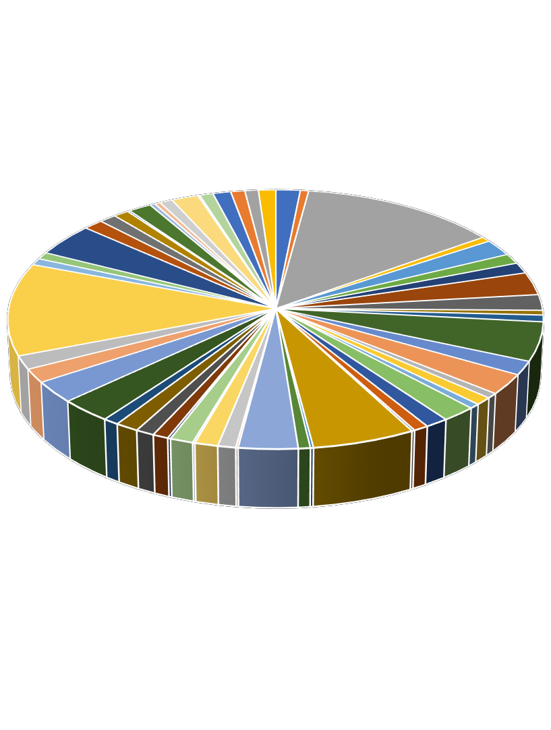

|  |  |  |  |  |  |  |
| --- | --- | --- | --- | --- | --- | --- |
| **LGAs** | **March 2020** | **September 2020** | **March 2021** | **September 2021** | **Increase** | **Decrease** |
| Abuja Municipal | 2% | 11% | 15% | 13% | - | 2% |
| Kosofe | 11% | 9% | 5% | 3% | - | 2% |
| Riyom | 7% | 6% | 3% | 2% | - | 1% |

|  |  |  |  |  |  |  |
| --- | --- | --- | --- | --- | --- | --- |
| Makurdi | 5% | 6% | 3% | 4% | 1% | - |
| Bauchi | 7% | 6% | 3% | 3% | - | - |
| Mushin | 5% | 4% | 2% | 1% | - | 1% |
| Eti-Osa | 4% | 0% | 2% | 1% | - | 1% |
| Ifako-Ijaye | 3% | 2% | 1% | 0% | - | 1% |
| Gboko | 3% | 2% | 1% | 2% | 1% | - |
| Suleja | 2% | 1% | 1% | 1% | - | - |
| Lagos Island | 0% | 0% | 20% | 12% | - | 8% |
| Ibeju/Lekki | 0% | 0% | 7% | 6% | - | 1% |
| Konshisha | 0% | 0% | 5% | 3% | - | 2% |
| Dunukofia | 0% | 0% | 4% | 3% | - | 1% |
| Bwari | 0% | 0% | 1% | 5% | 4% | - |
| Kuje | 0% | 0% | 0% | 2% | 2% | - |
| Awka North | 4% | 4% | 3% | 2% | - | 1% |
| Aba North | 0% | 0% | 0% | 2% | 2% | - |
| Danbatta | 1% | 1% | 0% | 2% | 2% | - |
| Bichi | 0% | 0% | 2% | 2% | - | - |
| Kwande | 3% | 3% | 2% | 2% | - | - |
| Oshodi- Isolo | 6% | 5% | 3% | 2% | - | 1% |

***Table 3: Table showing percentage increase & decrease among some LGAs***

The table above shows trends with regards to LGAs with the highest violations of petty offences as captured in past and this reporting period. **Abuja Municipal** in March 2020 was captured at 2%. In September 2020, it was recorded at 11% which reflects an increase of 9%, captured at 15% which was a further increase of 4% in March 2021. In September 2021 however, there was a decrease to 13%. **Kosofe** was initially captured at 11% in the first report produced in March 2020. A decrease of 2% was shown in the last report in September 2020 i.e., to 9% and a further decrease of 4% in March 2021 to 5%. A decrease to 3% was captured in September 2021. **Riyom** was captured at 7% in March 2020. A decrease of 1% was recorded in September 2020. In March 2021 and September 2021, it was recorded at 5% and 3% respectively. **Makurdi** was documented at 5% in March 2020, in September 2020 there was an increase of 1%. In March 2021 however, it was recorded at 3% which shows a decrease of 3%. In September 2021, an increase of 1% was recorded. **Bauchi** was captured at 7% in March 2020 and a decline to 6% in September 2020. A decrease of 3% was recorded in March 2021 and September 2021 respectively. **Mushin** was captured at 5% in March 2020 and 4% in September 2020, with a further decline to 2% in March 2021. In September 2021, it was recorded at 1%. **Eti-Osa** in March 2020 was recorded at 4%, in September 2020 a decline to an insignificant record of less than 1% was documented and in March 2021, there was an increase to 2%. In September 2021 however, it was recorded at an insignificant amount of less than

1%. **Ifako-Ijaye** was documented at 3% in March 2020, a decrease to 2% was recorded in September 2020 and a further decrease to 1% in March 2021. In September, it had an insignificant reportage of less than 1%. **Gboko** was documented at 3% in March 2020, a decrease to 2% was recorded in September 2020 and a further decrease to 1% in March 2021. An increase to 2% was recorded in September 2021. **Suleja** in March 2020 was captured at 2% and a decline to 1% recorded in September 2020, March 2021 and September 2021 respectively. **Lagos Island** had an insignificant reportage of less than 1% in March 2020 and September 2020, an increase of 20% was recorded in March 2021 and a decrease to 12% in September 2021. **Ibeju/Lekki** had an insignificant reportage of less than 1% in March 2020 and September 2020, an increase of 7% was captured in March 2021. In September 2021, a decline to 6% was recorded. **Konshisha** had an insignificant reportage of less than 1% in March 2020 and September 2020 respectively. In March 2021, it recorded an increase of 5% and in September 2021, a decrease to 3%. **Dunukofia** had an insignificant reportage of less than 1% in March 2020 and September 2020. An increase of 4% was however recorded in March 2021. In September 2021, a decrease to 3% was captured. **Bwari** had an insignificant reportage of less than 1% in March 2020 and September 2020, an increase of 1% was captured in March 2021. In September 2021, an increase of 5% was recorded. **Kuje** had an insignificant reportage of less than 1% in March 2020, September 2020 and March 2021 respectively. In September 2021, it recorded an increase of 2%. **Awka-North** in March 2020 and September 2020 was captured at 4%, a decline to 3% recorded in March 2021 and a further decline to 2% in September 2021. **Aba North** had an insignificant reportage of less than 1% in March 2020, September 2020 and March 2021. An increase of 2% was however recorded in September 2021. **Danbatta** was recorded at 1% in March 2020 and September 2020. An insignificant report to less than 1% was captured in March 2021 and an increase of 2% in September 2021. **Bichi** had an insignificant reportage of less than 1% in March 2020 and September 2020 respectively. In March 2021, and September 2021, an increase to 2% was recorded. **Kwande** was recorded at 3% in March 2020 and September 2020 respectively. In March 2021 and September 2021, it was documented at 2%. **Oshodi-Isolo** was recorded at 3% in March 2020. In September 2020, a decline of 1% i.e., 5% was captured. In March 2021 a decrease to 3% was documented and a further decrease to 2% in September 2021.

**PETTY OFFENCES VIOLATIONS BASED ON AGE**

Disaggregation by age, as shown in the pie chart below on the other hand, reveals that the 25-40 years group suffers the highest violation rate with 45%. Age bracket 20-24 years ranked second at 32%, while 10-19-year group ranked third

at 14%. Age bracket 40years+ came fourth at 6%, with 6-9-years at 2% and 0-5 years at 1%.

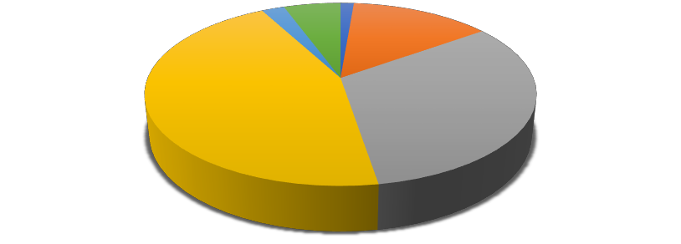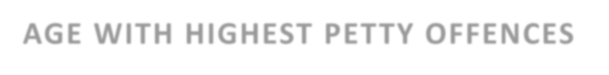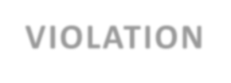

**AGE WITH**

40yrs+ 6%

6-9yrs 2%

**HIGHEST PETTY OFFENCES**

**VIOLATION**

0-5yrs

1%

10-19yrs

14%

25-40yrs

45%

20-24yrs

32%

0-5yrs 10-19yrs 20-24yrs 25-40yrs 6-9yrs 40yrs+

***Fig 7: Age with the highest Petty Offences violation***

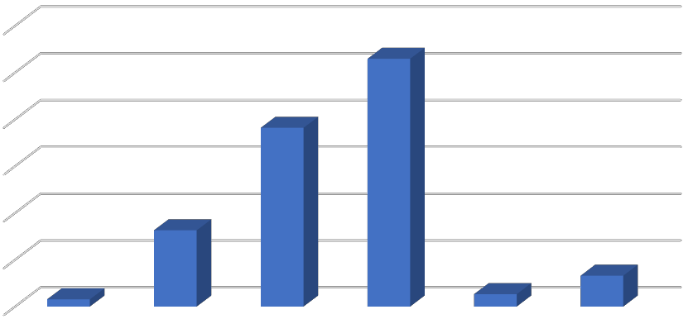

BAR CHART ANALYSIS OF AGE WITH HIGHEST

PETTY OFFENCES VIOLATIONS

1200

1000

800

600

400

200

0

0-5yrs 10-19yrs 20-24yrs 25-40yrs 6-9yrs

40yrs+

***Fig 8: Bar Chart Analysis of Ages with the highest Petty Offences violation***

|  |  |  |  |  |  |  |
| --- | --- | --- | --- | --- | --- | --- |
| **Age** | **March 2020** | **September 2020** | **March 2021** | **September 2021** | **Increase** | **Decrease** |
| 0 – 5  years | 2% | 1% | 0% | 1% | 1% | - |
| 6 – 9  years | 2% | 2% | 0% | 2% | 2% | - |
| 10 – 19  years | 29% | 24% | 14% | 14% | - | - |
| 20 – 24  years | 37% | 32% | 30% | 32% | 2% | - |
| 25 – 40  years | 30% | 41% | 56% | 45% | - | 11% |
| 40 years  + | 0% | 0% | 0% | 6% | 6% | - |

***Table 4: Table showing percentage increase & decrease across age brackets***

The above table shows trends with regards to Age with the highest violations of petty offences as captured in past and this reporting period. **0-5 years** in March 2020 was captured at 2%. In September 2020, it was recorded at 1% which reflects a decrease of 1%, and in March 2021, there was a further decrease to an insignificant number of less than 1%. In September 2021, an increase of 1% was recorded. **6-9 years** was captured at 2% in March 2020 and September 2020. A decrease to an insignificant number of less than 1% was recorded in March 2021 and an increase to 2% was captured in September 2021. **10-19 years** was captured at 29% in March 2020. A decrease to 24% was recorded in September 2020 and a further decrease to 14% in March 2021 and September 2021 respectively. **20-24 years** was documented at 37% in March 2020, in September 2020 there was a decrease to 32% and a further decrease to 30% in March 2021. In September 2021, an increase of 2% was recorded i.e., 32%. **25-40 years** was captured at 30% in March 2020. An increase to 41% was recorded in September 2020 and a further increase to 56% was recorded in March 2021. A decrease to 45% was captured in September 2021. **40years+** was captured at an insignificant number of less than 1% in March 2020, September 2020 and March 2021. An increase to 6% was however recorded in September 2021.

**PETTY OFFENCES VIOLATIONS/INDICATORS**

The chart below is a reflection of Petty offences violations/indicators as captured in this reporting period. Unlawful Arrest ranked highest at 12%, closely followed by Emotional Abuse at 11%. Verbal Abuse and Harassment ranked third at 10% respectively. Detention and Assault ranked fourth at 9% respectively, with

Battery, Torture and Corporal Punishment coming fifth at 5% respectively. Extortion was recorded at 4% and Blackmail at 3%. Rape/Sexual Assault, Invasion of Privacy, Molestation, Exorbitant Fine, Incarceration, Stigmatization and Seizure of Goods were recorded at 2% respectively. False Imprisonment, Exploitation of Personal Belongings, Starvation/Deprivation of Food, Denial of Legal Representation and Confiscation of Property all ranked 1%. Seizure of Vehicle Plate Number, Damage of Vehicle and Forced Eviction was recorded at an insignificant amount of less than 1% respectively.

Confiscation 1%

Seizure of goods

Detention 9%

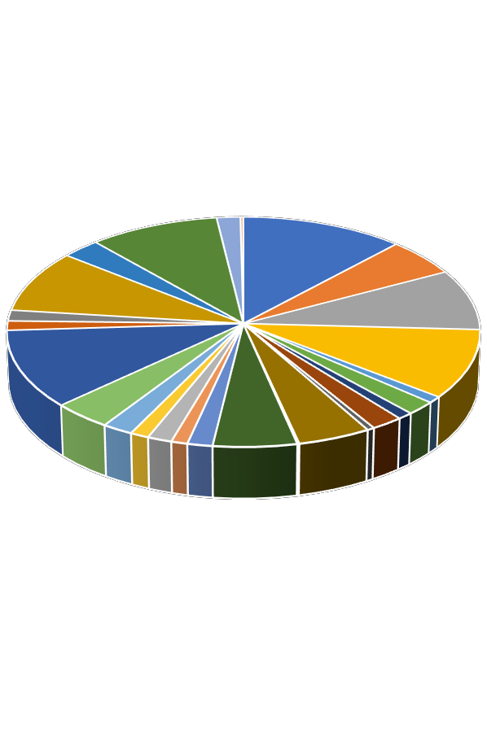

Assault 9%

Verbal Abuse 10%

Emotional Abuse 11%

# Petty Offences by violation types/indicators

Blackmail

2% 3%

Harassment 10%

Rape/Sexual Assault 2%

Unlawful Arrest 12%

Seizure of Vehicle Plate Number

0%

Battery 5%

Unlawful Arrest Battery

Assault Verbal Abuse

False Imprisonment

Invasion of Privacy

Exploitation of personal belongings Molestation

Extortion 4%

Incarceration

2%

Denial of legal representation 1%

Stigmatization 2%

Starvation/food deprivation

Exorbitant Fine 2%

Corporal

Damage of vehicle 0%

Molestation 2%

False Imprisonment 1%

Invasion of Privacy 2%

Exploitation of personal belongings

Forced Eviction Torture

Damage of vehicle

Corporal purnishment Exorbitant Fine

Starvation/food deprivation Stigmatization

Denial of legal representation Incarceration

Extortion

1% purnishment

5%

Torture

5%

Forced Eviction 1%

0%

***Fig 9: Petty Offences by Violation Types/Indicators***

Bar Chart Analysis of Petty Offences Types/Indicators

***Fig 10: Bar Chart analysis of Petty Offences Violations/Indicators***

1600

1400

1200

1000

800

600

400

200

0

Unlawful Arrest

Battery Assault Verbal Abuse

False Imprisonment Invasion of Privacy

Exploitation of…

Molestation Forced Eviction

Torture Damage of vehicle Corporal purnishment

Exorbitant Fine Starvation/food… Stigmatization

Denial of legal…

Incarceration

Extortion Emotional Abuse

Confiscation Seizure of goods

Detention Blackmail Harassment Rape/Sexual Assault

Seizure of Vehicle…

|  |  |  |  |  |  |  |
| --- | --- | --- | --- | --- | --- | --- |
| **Violations/Indicators** | **March 2020** | **September 2020** | **March 2021** | **September 2021** | **Increase** | **Decrease** |
| Verbal Abuse | 16% | 15% | 11% | 10% | - | 1% |
| Emotional Abuse | 16% | 15% | 12% | 11% | - | 1% |
| Unlawful Arrest | 15% | 13% | 13% | 12% | - | 1% |
| Detention | 13% | 11% | 9% | 9% | - | - |
| Assault | 11% | 10% | 9% | 9% | - | - |
| Harassment | 7% | 8% | 10% | 10% | - | - |
| Corporal Punishment | 5% | 6% | 5% | 5% | - | - |
| Torture | 2% | 4% | 4% | 5% | 1% | - |
| Battery | 3% | 4% | 5% | 5% | - | - |
| Incarceration | 1% | 2% | 2% | 2% | - | - |
| Stigmatization | 2% | 1% | 1% | 2% | 1% | - |
| Exorbitant Fine | 1% | 0% | 1% | 2% | 1% | - |
| Rape/Sexual Assault | 1% | 1% | 1% | 2% | 1% | - |
| Invasion of Privacy | 0% | 0% | 2% | 2% | - | - |
| Molestation | 1% | 1% | 2% | 2% | - | - |
| Blackmail | 1% | 2% | 3% | 3% | - | - |
| Extortion | 2% | 2% | 3% | 4% | 1% | - |
| Seizure of goods | 1% | 1% | 2% | 2% | - | - |
| Exploitation of personal belongings | 0% | 0% | 1% | 1% | - | - |
| Starvation/Food deprivation | 0% | 0% | 1% | 1% | - | - |

|  |  |  |  |  |  |  |
| --- | --- | --- | --- | --- | --- | --- |
| Denial of legal representation | 0% | 0% | 1% | 1% | - | - |

***Table 5: Table showing percentage increase & decrease on Petty Offences Violations/Indicators***

The table above shows trends with regards to Petty Offences types/indicators as captured in past and this reporting period. **Verbal Abuse** in March 2020 was captured at 16%%. In September 2020, it was recorded at 15% which reflects a decrease of 1%. In March 2021 and September 2021, there was a further decrease to 11% and 10% respectively. **Emotional Abuse** was captured at 16% in the first report produced in March 2020. A decrease to 15% was recorded in September 2020 and a further decrease to 12% and 11% in March 2021 and September 2021. **Unlawful Arrest** was captured at 15% in March 2020, a decrease to 13% was recorded in September 2020 and March 2021. A further decrease to 12% was recorded in September 2021. **Detention** was documented at 13% in March 2020, in September 2020 there was a decrease to 11% and in March 2021, it was recorded at 9% which shows a decrease of 2%. In September 2021, it remained reported at 9%. **Assault** was captured at 11% in March 2020 and a decline to 10% in September 2020. A decrease to 9% was recorded in March 2021 and September 2021. **Harassment** was captured at 7% in March 2020 and 8% in September 2020, with a further increase to 10% in March 2021 and September 2021. **Corporal Punishment** in March 2020 was recorded at 5%, in September 2020 6% and 5% in March 2021 & September 2021 respectively. **Torture** was documented at 2% in March 2020, an increase to 4% was recorded respectively in September 2020 and in March 2021. In September 2021, it was recorded at 5%, which is an increase of 1%. **Battery** in March 2020 was captured at 3% and an increase to 4% in September 2020. A further increase to 5% was recorded in March 2021 and September 2021 respectively. **Incarceration** was captured at 1% in March 2020 and an increase to 2% was recorded in September 2020, March 2021 and September 2021 respectively. **Stigmatization** was captured at 2% in March 2020 and a decrease to 1% was recorded in September 2020 and March 2021 respectively. An increase to 2% was recorded in September 2021. **Exorbitant Fine** was captured at 1% in March 2020 and a decline to less than 1% in September 2020. An increase to 1% was recorded in March 2021 and a further increase to 2% in September 2021. **Rape/Sexual Assault** had a constant reportage of 1% in March 2020, September 2020 and March 2021 respectively. An increase to 2% was however recorded in September 2021. **Invasion of Privacy** was captured at 0% in March 2020 and September 2020 respectively. An increase to 2% was recorded in March 2021 and September 2021 respectively. **Molestation** was captured at 1% in March 2020 and September 2020 respectively, with an increase to 2% in March 2021 and September 2021.

**Blackmail** was recorded at 1% in March 2020, at 2% in September 2020 and 3% in March 2021 & September 2021 respectively. **Extortion** was recorded at 2%

in March 2020 and in September 2020 respectively. An increase to 3% was captured in March 2021 and a further increase to 4% in September 2021. **Seizure of goods** was recorded at 1% in March 2020 and September 2020 respectively. In March 2021 and September 2021 however, it was recorded at 2%. **Exploitation of personal belongings, Starvation/food deprivation and Denial of legal representation** had an insignificant reportage of less than 1% in March 2020 and September 2020 respectively. An increase to 1% each was recorded in March 2021 and September 2021.

**CONCLUSION**

The updated petty offences violation report is a representation of documented violations over the period April 2021 to September 2021. It should also be stated that the data represented in this report is based only on that obtained from the online portal (Lawyers Alert Documentation Tool “LadockT”). It is hoped that this report will serve as a huge resource for advocacy towards the decriminalization and declassification of petty offences in Nigeria.